INTEGRATIVE COURSE IN PSYCHOLOGY (ICOPSYCH)

ANALYSIS ON THE RESULT OF POST-TEST EXAMINATION IN PSYCHOLOGICAL ASSESSMENT
MAY 31, 2025

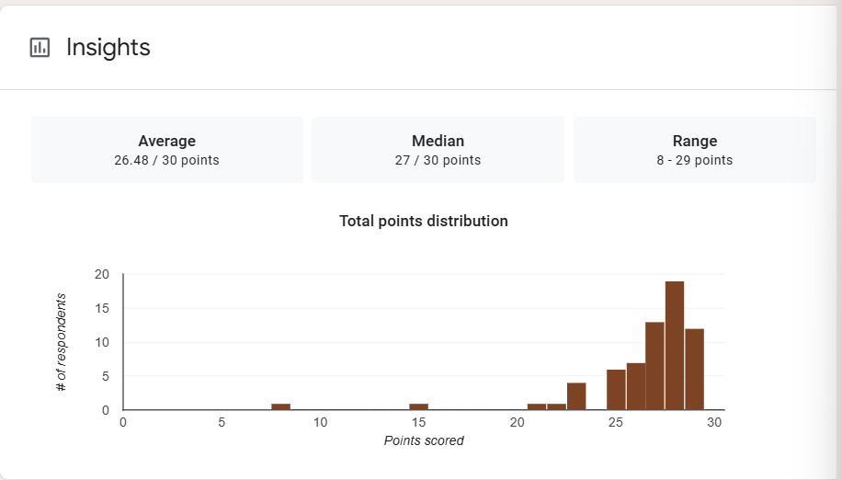

1. Mean Score: The mean score of 26.48 corresponds to 88.3%, indicating very strong overall performance. On average, test-takers performed well, suggesting a high level of understanding or mastery of the material.

2. Median Score: The median score of 27 is slightly higher than the mean, suggesting a left-skewed distribution. This means that more than half of the participants scored 27 or above, while a few lower scores pulled the average down slightly.

3. Range: The range of 21 points (from 8 to 29) indicates substantial variability in performance. These low scores suggest that a minority of test-takers may have struggled significantly, possibly due to gaps in knowledge, lack of preparation, or other factors.

Interpretation Summary:

-The test results show strong performance overall, with a high mean (26.48) and very high median (27).

-The wide range (8–29) reflects a mix of very high and notably low performers, indicating that while the majority mastered the material, a few students may need additional support or intervention.

-In general, the results point to effective instruction for most of the group, but also highlight performance disparities worth addressing.

RATIONALIZATION:

DIFFICULT QUESTIONS:

